Learning Goal: To make links between texts I have read
Context: The Little Mouse’s Book of Fears and Matilda’s Cat by Emily Gravett
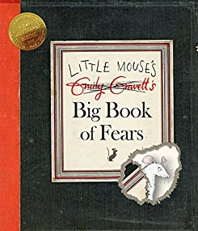
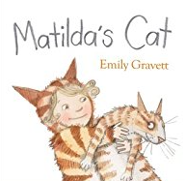

Describe each of the characters above and then compare them to each other.
What are the similarities and differences of the characters and of the books?

Learning Goal: To make links between texts I have read
Context: The Little Mouse’s Book of Fears and Matilda’s Cat by Emily Gravett

Describe each of the characters above and then compare them to each other.
What are the similarities and differences of the characters and of the books?

